Network Basics

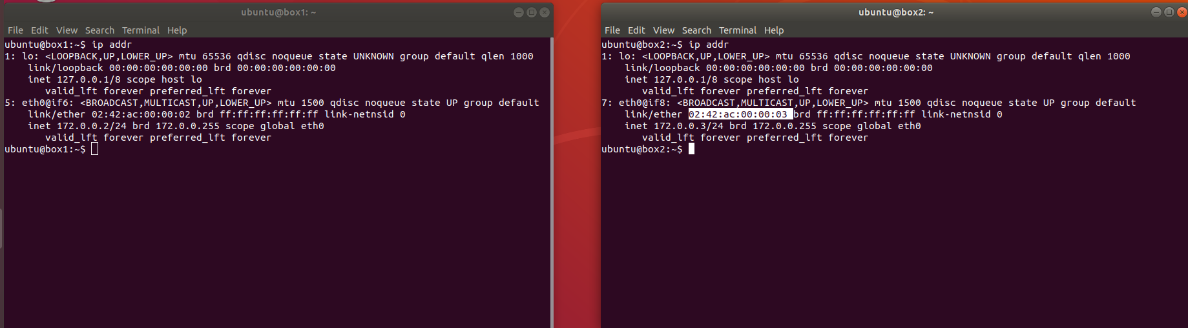

I ran “ip addr” on both boxes to get info on their IP and MAC addresses.

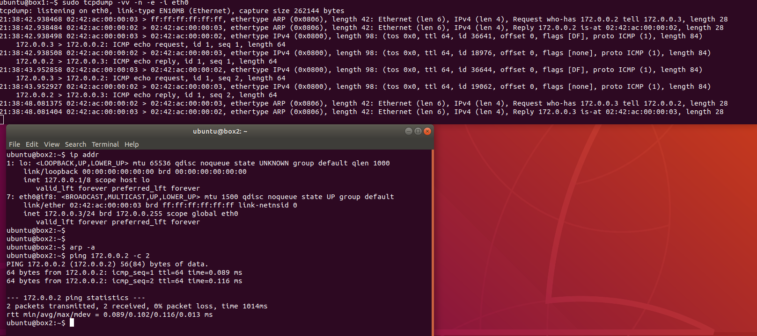

I have run the ping command and used box2 to ping box1 while traffic was being read.

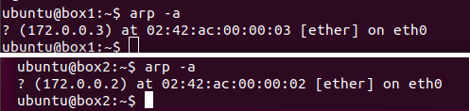

I’ve run arp to show that both boxes now know each other’s MAC addresses.

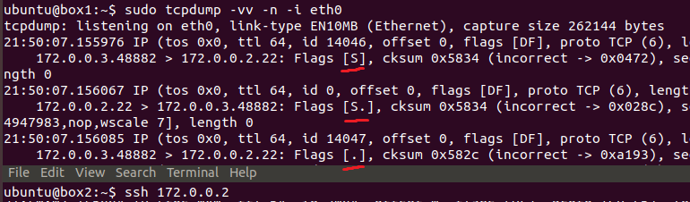

Attempted to initiate ssh connection from box2 to box1. TCP “three-way handshake” shown with proper flags.

Routing Basics

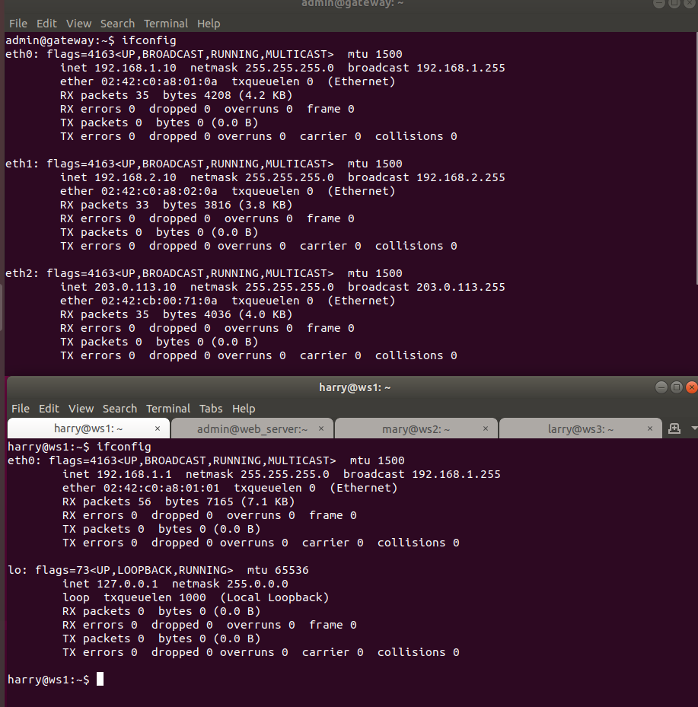

Ran ifconfig on all computers to understand connection between them.

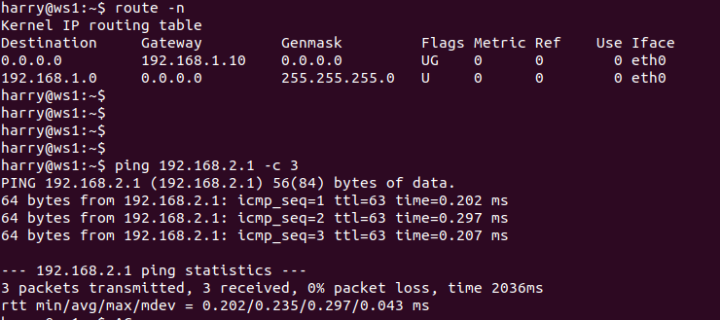

Ping sent from ws1 to ws2 via gateway. Success.

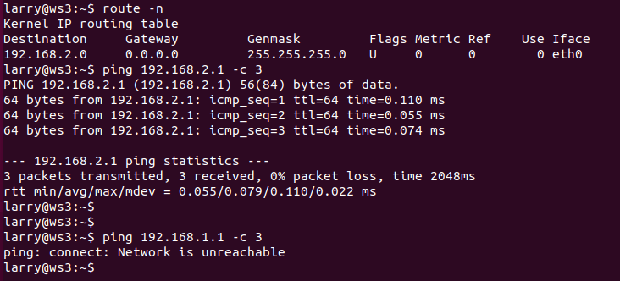

Ping sent from ws3 to ws2. Success. Ping sent from ws3 to ws1 failed due to no routing table entry.

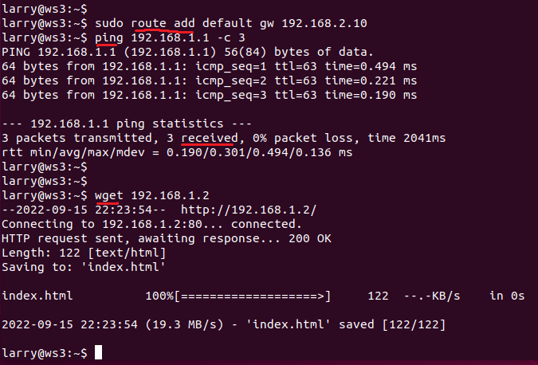

Defined default gateway using route command. Pinged from ws3 to ws1. Success.\

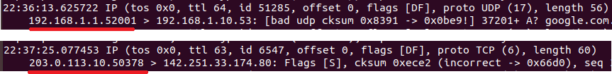

(Above) Ran tcpdump on subnet containing ws1. Local addresses can be seen.

(Below) Ran tcpdump on ISP’s subnet. Public addresses are seen.

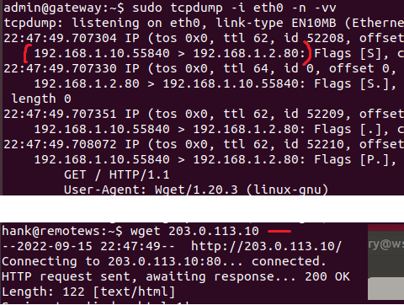

(Below) Queried web server with wget from remote workstation.

(Above) Tcpdump on eth0 reveals destination addres is web server and source address is gateway.